# Parish of Mattersey and Mattersey Thorpe

# Neighbourhood Development Plan

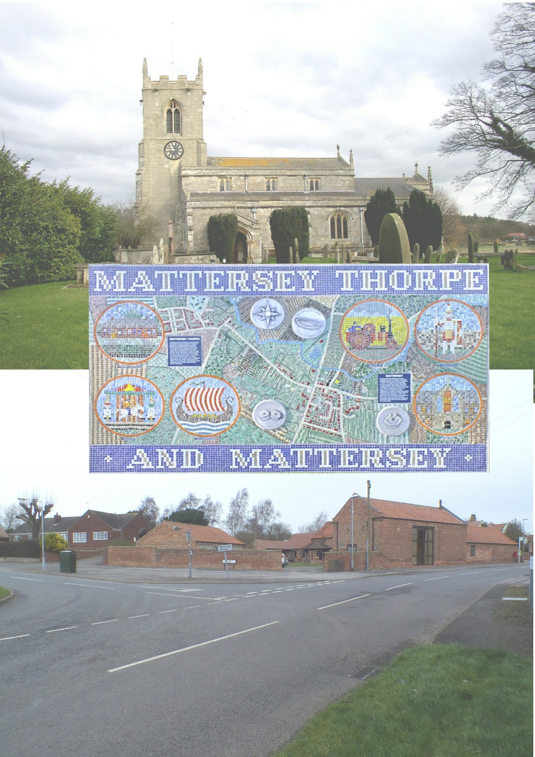

# 

# Residents Survey – March 2016

# Initial Report – 31st March 2016

Contents

**Introduction** 3

**Survey detail** 4

**About the population** 5

**Transport** 9

**Employment** 11

**Housing** 14

**Local Environment** 16

**School** 20

**Recreation** 21

## Introduction

Neighbourhood planning gives communities direct power to develop a shared vision for their neighbourhood and shape the development and growth of Mattersey and Mattersey Thorpe.

A neighbourhood plan will let us choose where we want new homes, shops and businesses to be built, have our say on what those new buildings should look like and what infrastructure should be provided, and in some circumstances, grant planning permission for the new buildings we want to see go ahead. Neighbourhood planning provides a powerful set of tools for local people to ensure that they get the right types of development for our community where the ambition of the neighbourhood is aligned with the strategic needs and priorities of the wider local area.

This survey is the first stage in helping us produce a Neighbourhood plan for the parish of Mattersey and Mattersey Thorpe.

## Survey detail

The forms were hand delivered with an explanation of the purpose of the survey given to the person (adult) who answered the door. The questionnaires were delivered on the 18 March 2016 and collected on the 20 March 2016.

311 properties received forms. Collections were made by members of the parish at varying times with up to 3 attempts to recover the forms. The vast majority of the forms were collected in this method with 3 additional forms being returned at a slightly later time.

In total 200 completed questionnaires were returned, based on a universe of 311 households this is a 64.3% response rate. This level of response is reflected with a high confidence level of 95% ± 5%. In reality any question with a response in excess of 172 responses would have the equivalent confidence level.

The questionnaire was designed by the Parish Council with input from Osiris MR. Osiris MR is a full service market research consultancy based in Nottingham providing customers with bespoke market research solutions across the UK. Quality and standards are important to us which is why we are Market Research Society Company Partners and accredited with ISO 20252:2012 which is the international standard for market research. This report has been written by a certified market research professional and full member of the Market Research Society.

The questionnaire was professionally designed and printed in order to highlight the importance of the exercise to the parishioners. A full colour booklet was utilised. The questionnaire is designed to be confidential without the inclusion of names and addresses, although postcode has been collected for overview purposes.

The remainder of the report will look at the data provided by the parishioners.

**About the population**

Parishioners were asked to provide information about themselves/the household in which they live in.

76.8% of responses from 198 responses were provided by respondents answering for the household whilst 23.2% were complete by individuals.

In order to understand how long people have lived in the Parish respondents were asked to state how long they had lived in Mattersey/Mattersey Thorpe. This data was wide ranging with responses from 0 to 77 years. In order to better understand the data the responses were grouped roughly to 5 year splits.

|  |  |  |
| --- | --- | --- |
| **Total responses** | **192** | **100.00%** |
| 1 year or less | 17 | 8.9% |
| 2 to 5 years | 31 | 16.1% |
| 6 to 10 years | 26 | 13.5% |
| 11 to 15 years | 23 | 12.0% |
| 16 to 20 years | 23 | 12.0% |
| 21 to 25 years | 11 | 5.7% |
| 26 to 30 years | 16 | 8.3% |
| More than 30 years | 45 | 23.4% |

¼ of the respondents have lived in the villages for less than 5 years, which is nearly equalled by those who have lived there for over 30 years. There is a fairly even spread of respondents between 6 and 20 years residence within the villages. There is a significant drop, to 5.7%, in the proportion of residents with a tenure between 21 and 25 years although it would take further research to understand the dynamics of this result.

When looking at the age profile of parishioners there is a noticeable bias in the age range towards older people with over 59.4% of respondents showing age ranges within their household over 45 years old. ⅕ of the responding population falls into the children category i.e. those people under the age of 18 who should be in education or training.

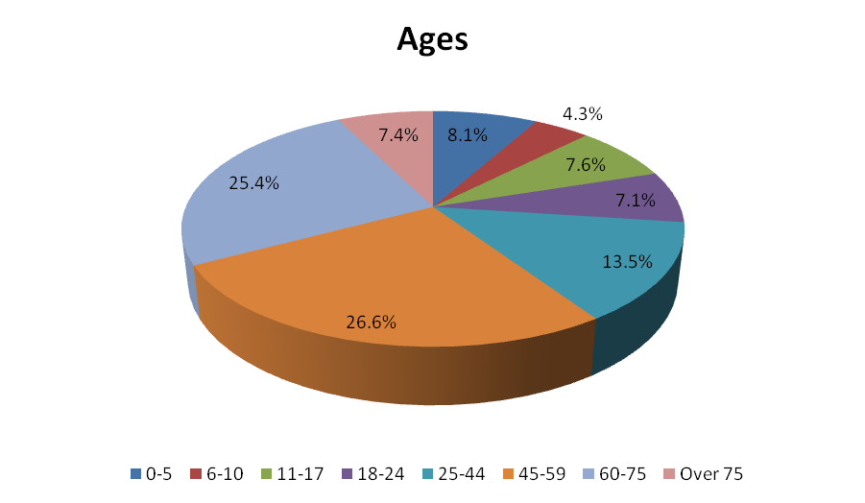

|  |  |  |
| --- | --- | --- |
| **Base\*** | **421** | **100.0%** |
| 0-5 | 34 | 8.1% |
| 6-10 | 18 | 4.3% |
| 11-17 | 32 | 7.6% |
| 18-24 | 30 | 7.1% |
| 25-44 | 57 | 13.5% |
| 45-59 | 112 | 26.6% |
| 60-75 | 107 | 25.4% |
| Over 75 | 31 | 7.4% |

*\*The base figure represents the total number of people provided by each age band.*

The participants were then asked to provide information with regard to how they came to live in the villages. This question asked for all of the reasons why rather than a primary reason.

|  |  |  |
| --- | --- | --- |
| **Base** | **193** | **100.0%** |
| Born here/ Moved with family | 50 | 25.9% |
| Ease of travel to work | 20 | 10.4% |
| Relatives living nearby | 36 | 18.7% |
| Retirement | 22 | 11.4% |
| To be in rural location | 96 | 49.7% |
| Work in area | 32 | 16.6% |

Nearly half of the respondents 49.7% cited that *“To be in a rural location”* with the next closest explanation being *“Born here / moved with family”* 25.9% if you include those people with *“Relatives living nearby”* 18.7% it shows that familial connection account for nearly 45% of the people living in Mattersey or Mattersey Thorpe.

When looking toward the future intention of the residents 21.4% of respondents are looking to move in the near future, whilst 78.6% are unlikely to move.

In following up with those people who may move in the near future it should be recognised that the number of people is relatively small so any information may only be used as a guide and does not have a significant level of confidence.

|  |  |  |
| --- | --- | --- |
| **Base** | **32** | **100.0%** |
| Better local amenities | 12 | 37.5% |
| Better transport connections | 5 | 15.6% |
| Further Education | 8 | 25.0% |
| Less rural isolation | 12 | 37.5% |
| Marriage | 5 | 15.6% |
| Social Care | 3 | 9.4% |

With the two of the most popular responses being *“better local amenities”* and *“less rural isolation”* both having 37.5% it may not be surprising that 67% of people who responded may move not only outside of the village but also outside of Bassetlaw.

|  |  |  |
| --- | --- | --- |
| **Base** | **40** | **100.0%** |
| Another dwelling in Mattersey/ Mattersey Thorpe | 5 | 12.5% |
| Elsewhere in Bassetlaw | 16 | 40.0% |
| Outside of Bassetlaw | 27 | 67.5% |

The respondents were also asked about disabilities within the household. Only 18.5% of respondents claim a disability within their household. Once again with only 36 respondents the subsequent data with regard to disability needs the data may only be used as an indicator rather than categorical.

|  |  |  |
| --- | --- | --- |
| **Base** | **Require** | **Use** |
| **100.0%** | **100.0%** |
| Wheelchair access | 60.0% | 38.5% |
| Community Health services | 80.0% | 69.2% |
| Community Transport | 26.7% | 15.4% |

In all cases the amount of usage appears to be less than the actual requirement. It is worth noting that the highest requirement is for Community Health Services 80% but only 69.2% use it.

Finally where a disability was mentioned respondents were asked to identify new services they would like to see available locally. The comments are listed below.

|  |
| --- |
| A shop would be good |
| Don't know what is available currently |
| Home communion |
| Kissing gates and narrow paths are inaccessible for mobility scooter/wheelchair |
| Medical Centre |
| More seats scattered around the village |
| More wheelchair friendly pavements |
| Would like to have more buses |

**Transport**

The next section of the survey looks at transport within the Parish.

In trying to understand the transport needs of the parishioners the first transport question was designed to understand the number of vehicles in the household.

|  |  |  |
| --- | --- | --- |
|  | **Owned** | **Used by** |
| Private Car | 293 | 310 |
| Motorcycle or Scooter | 19 | 14 |
| Bicycle | 101 | 91 |
| Works van | 27 | 27 |

Private cars are most prevalent within the parish with 171 respondents there are on average 1.7 cars per respondent households. The maximum number identified was 5 in a single household.

The second most popular mode of transport available within the villages are bicycles with 101 being owned although they are only used by 91 people.

There are understandably fewer works vans with only 27 identified as you would expect this is the same number as people using them.

Interestingly there are significantly more motorcycles/scooters than users, this is in part explained by one household having access to 6 motorcycles/scooters but only having 2 users.

Looking more widely from private transport villagers were asked about public transport usage within the area.

|  |  |  |  |
| --- | --- | --- | --- |
|  | **No. people** | **total applicable\*** | **% population responding** |
| School bus | 24 | 84 | 28.6% |
| Public Service Bus | 90 | 421 | 21.4% |
| Taxi | 10 | 421 | 2.4% |

*\*The applicable number of people is based on the number of people in age groups i.e. 0-17 for school services and all age groups for Public Bus and Taxi services (assumes all children below 17 may need to access school bus but may be limited to only 11+ = 32 people which would make utilisation 75%)*

Looking more widely respondents were also ask the frequency with which they used other transport infrastructure which links the villages to the wider country/world.

|  |  |  |  |  |  |  |
| --- | --- | --- | --- | --- | --- | --- |
|  | **Total** | **Weekly** | **Monthly** | **3 Monthly** | **6 Monthly** | **Yearly** |
| Retford Railway Station | 115 | 8 | 16 | 21 | 29 | 41 |
|  | (57.5%) | 7.0% | 13.9% | 18.3% | 25.2% | 35.7% |
| Doncaster Railway Station | 63 | 3 | 6 | 10 | 14 | 30 |
|  | (31.5%) | 4.8% | 9.5% | 15.9% | 22.2% | 47.6% |
| Finningley/ Robin Hood Airport | 70 | - | 1 | 3 | 10 | 56 |
|  | (35.0%) | - | 1.4% | 4.3% | 14.3% | 80.0% |

*(% of respondents) Respondents were limited to only pick the relevant frequency with which they actually use the service.*

57.5% of respondents use Retford Railway Station within an annual cycle, whilst only 7% of users use it each week over the course of 3 months this rises to 39.2%.

Doncaster Railway Station is used less frequently by the general population (31.5%) with nearly 70% using it twice or less throughout the year.

Although airports may be associated with vacations it is worth noting that 5.7% of people who said that they use Finingley/Robin Hood do on a quarterly basis. Although 80% of responding users only use the airport annually; although you may infer this is associated to an annual holiday this could not be confirmed through this research project and additional research would need to be conducted.

**Employment**

In developing the Neighbourhood plan it is important to consider the employment needs of the villagers. This section of the survey and report look at the employment across Mattersey and Mattersey Thorpe.

*Please Note: The age band question would not facilitate a true representation of the working population due to the inclusion of the 17 year old respondents in the working classification in addition to the ability of people to work in some capacity long after the notional retirement date of 65. There are some situations where people may also be able to answer multiple categories such as full time education who are looking for or employed in part time working.*

*To this end percentages will be based on the number of people in each categorisation. Whilst there is the possibility of people having both a full and part time role concurrently it has been assumed for the analysis that they are discrete individuals.*

In total 321 people from the responding households are included in the analysis.

|  |  |  |  |  |
| --- | --- | --- | --- | --- |
| **Base** | **Full time** | | **Part time** | |
| **277** |  | **44** |  |
| Self-employed - work from home | 10 | 3.6% | 13 | 29.5% |
| Self-employed - travel to work | 23 | 8.3% | 10 | 22.7% |
| Employed in the Parish | 7 | 2.5% | 2 | 4.5% |
| Employed outside of the Parish | 89 | 32.1% | 13 | 29.5% |
| Unemployed seeking work | 22 | 7.9% | 2 | 4.5% |
| Further education | 15 | 5.4% | 1 | 2.3% |
| Retired | 111 | 40.1% | 3 | 6.8% |

35% of people consider themselves retired either in full or in part.

52% of people in households who responded are in some type of work either full or part time.

Where people are employed full time they are likely to be employed outside of the Parish 32.1%. It is worth noting that 11.9% of people consider themselves to be self-employed although the majority have to travel to work. With further research it would be possible to understand their work activities.

Those people who are actively seeking full time work account for 7.9% of responses.

Very few people are employed full time within the Parish 2.5%.

When looking at part time workers the percentage of Parishioners who are self-employed and working from home is equivalent to those who have to travel outside of the parish 29.5%. Whilst over a 1/5 (22.7%) are self-employed and travel to work.

Another consideration researched by the survey is how far people have to travel for their work.

|  |  |  |  |  |
| --- | --- | --- | --- | --- |
| **Base** | **Full Time** | | **Part Time** | |
| **119** | **100.0%** | **30** | **100.0%** |
| 1 to 10 miles | 40 | 33.6% | 13 | 43.3% |
| 11 to 20 miles | 33 | 27.7% | 8 | 26.6% |
| 21 to 30 miles | 15 | 12.6% | 4 | 13.3% |
| Over 30 miles | 31 | 26.1% | 5 | 16.7% |

For full time workers around a 1/3 are employed within 10 miles of their home, which means that 2/3 of workers are travelling more than 10 miles to get to work. 26.1% of responders are travelling more than 30 miles.

Part time workers are, based on these results, more likely to work locally with 43.3% saying they work within 10 miles home. While the numbers of respondents are low it should be noted that 16.7% are saying that they need to travel in excess of 30 miles for a part time role.

Looking toward the future the parishioners were asked whether business/commercial development should be encouraged.



*Base 187 respondents*

Where people agreed to business and commercial development they were also asked what type of work should this be?

|  |  |  |
| --- | --- | --- |
| **Base** | **119** | **100.00%** |
| Expansion of existing facilities | 74 | 62.20% |
| Home-Based work | 68 | 57.10% |
| New facilities | 94 | 79.00% |

Respondents were allowed to identify any or all of the options. The most popular option was *“New Facilities”* which garnered nearly 4 out of every 5 responses. The weakest option was the development of *“Home-based work”* but even this option was preferable to 57.1% of respondents

People were also asked what types of business they would like to see



*Note: The size of the words reflects its appearance in the responses*

Key themes appeared predominately looking at a pub or improved/new shops.

People were less willing to identify where they would like to see the new businesses appear, with numerous comments of *“Anywhere”*

**Housing**

Parishioners were also asked about their views on housing within the villages.

This question divided response with 51.3% of respondents rejecting the notion of more houses in the villages to 48.7% who believed there should be.

Where respondents agreed that there should be more housing in the parish they were asked to identify what types of property they should be.

|  |  |  |  |  |
| --- | --- | --- | --- | --- |
| **Rental Properties** | **Mattersey** | | **Mattersey Thorpe** | |
| **55** | **100.0%** | **55** | **100.0%** |
| Single person housing | 28 | 50.9% | 28 | 50.9% |
| Warden-controlled accommodation | 21 | 38.2% | 18 | 32.7% |
| Starter home (2 bedrooms) | 39 | 70.9% | 37 | 67.3% |
| Family homes (3-4 bedrooms) | 35 | 63.6% | 36 | 65.5% |
| Executive homes (5 or more bedrooms) | 7 | 12.7% | 6 | 10.9% |
| Homes with work unit attached | 13 | 23.6% | 11 | 20.0% |

|  |  |  |  |  |
| --- | --- | --- | --- | --- |
| **Purchased Properties** | **Mattersey** | | **Mattersey Thorpe** | |
| **73** | **100.0%** | **59** | **100.0%** |
| Single person housing | 24 | 32.9% | 17 | 28.8% |
| Warden-controlled accommodation | 14 | 19.2% | 4 | 6.8% |
| Starter home (2 bedrooms) | 58 | 79.5% | 47 | 79.7% |
| Family homes (3-4 bedrooms) | 58 | 79.5% | 45 | 76.3% |
| Executive homes (5 or more bedrooms) | 21 | 28.8% | 17 | 28.8% |
| Homes with work unit attached | 16 | 21.9% | 15 | 25.4% |

*The question was only answered by people who wanted more housing which means that the overall numbers for some responses will be low. This means that the data should only be used as a general indication.*

Whether looking at the rented sector or the purchased sector within both villages there is a desire for Starter and Family homes, where people actually specified an agreement for more houses.

Within the rented sector over half of respondents specified that there was a need for *single person housing* in both villages.

|  |  |  |  |  |
| --- | --- | --- | --- | --- |
| **Base** | **Rent** | | **Buy** | |
| **82** | **100.0%** | **143** | **100.0%** |
| Small sites next to existing housing | 67 | 81.7% | 114 | 79.7% |
| Large sites next to existing housing | 8 | 9.8% | 17 | 11.9% |
| Previously developed sites (ie Brownfield) | 41 | 50.0% | 85 | 59.4% |
| Open countryside (ie not previously built-on) | 14 | 17.1% | 22 | 15.4% |

*The number of responses for the rented sector is low and should only be used as an indicator, the purchased sector data is more robust.*

Looking at future planning in both the rented and purchased sectors respondents would prefer to see developments of small sites next to existing housing c.80%, and that where possible this should be on previously developed *brownfield* sites.

15%+ of respondents would be happy to see some development on *“greenfield”* sites.

Parishioners were also asked if they would like to see the open space between Mattersey and Mattersey Thorpe retained.

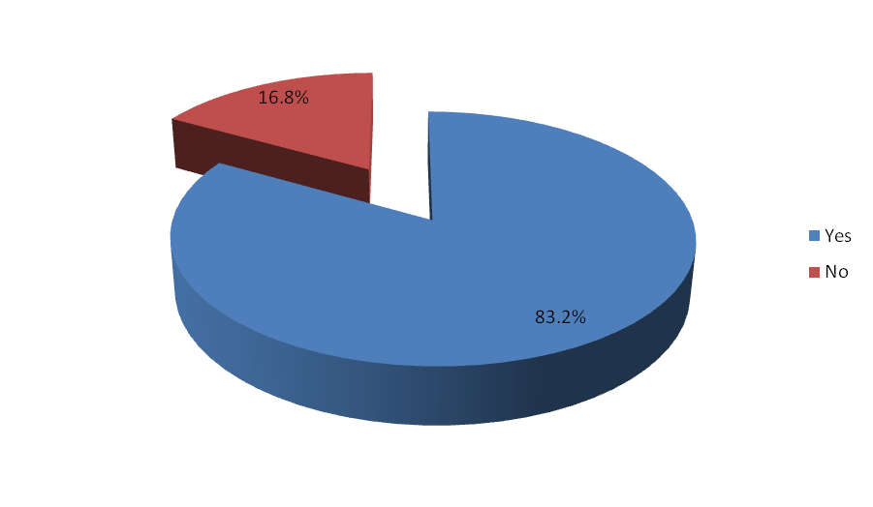

83.2% of respondents out of 191 respondents would like to see the space retained.

Parishioners were then asked if they had any suggestions for development sites within the villages.

**Local Environment**

In determining the future plan for the parish the views on the importance of various elements were put to the respondents.

In looking at the importance a weighted approach has been used.

|  |  |
| --- | --- |
| **Response** | **Weight** |
| No view | 0 |
| Not important | 1 |
| Low importance | 2 |
| Important | 3 |
| Very important | 4 |

By weighting the scores it is possible to measure the average score and determine the standard deviation from that given score. Standard deviation is simply a measure of how spread out the numbers are from the mean score. Standard deviation which are closer to zero show that the spread of answers given was tighter.

The first thing was what residents found most important about living in Mattersey and Mattersey Thorpe.

|  |  |  |  |  |  |  |  |  |
| --- | --- | --- | --- | --- | --- | --- | --- | --- |
|  | **Base** | **Mean** | **Standard Deviation** | **No view** | **Not important** | **Low importance** | **Important** | **Very important** |
| The Rural environment | 188 | 3.64 | 0.05 | 3 | - | 5 | 46 | 134 |
| 1.6% | - | 2.7% | 24.5% | 71.3% |
| Having a village shop | 193 | 3.4 | 0.06 | 2 | 5 | 17 | 58 | 111 |
| 1.0% | 2.6% | 8.8% | 30.1% | 57.5% |
| Mobile phone network access | 182 | 3.34 | 0.07 | 6 | 2 | 15 | 61 | 98 |
| 3.3% | 1.1% | 8.2% | 33.5% | 53.8% |
| Village heritage | 186 | 3.3 | 0.07 | 9 | - | 14 | 67 | 96 |
| 4.8% | - | 7.5% | 36.0% | 51.6% |
| Broadband access | 184 | 3.22 | 0.07 | 7 | 7 | 16 | 63 | 91 |
| 3.8% | 3.8% | 8.7% | 34.2% | 49.5% |
| Recreational facilities | 180 | 2.91 | 0.08 | 12 | 9 | 19 | 83 | 57 |
| 6.7% | 5.0% | 10.6% | 46.1% | 31.7% |
| Mattersey and Mattersey Thorpe working as a community | 186 | 2.86 | 0.08 | 11 | 12 | 30 | 72 | 61 |
| 5.9% | 6.5% | 16.1% | 38.7% | 32.8% |
| All Saints Church | 181 | 2.85 | 0.08 | 12 | 10 | 24 | 82 | 53 |
| 6.6% | 5.5% | 13.3% | 45.3% | 29.3% |
| Mattersey School Local Transport links | 171 | 2.77 | 0.11 | 24 | 7 | 23 | 48 | 69 |
| 14.0% | 4.1% | 13.5% | 28.1% | 40.4% |

*All answers have been ranked based on the mean score.*

The most important thing, as ranked by respondents with a mean score of 3.64, is the *rural environment* with 71.3% of respondents rating this as very important and nearly 96% of respondents rating it as either Important or Very Important.

*Having a village shop* was the next highest with a mean score of 3.4 and 87.6% of respondents rating this as either Important or Very Important.

*Mobile phone network access* also scored highly with an average score of 3.34 and 87.3% of respondents rating it as Important or Very Important.

Parishioners were then asked to rate how important specific aspects were in protecting the local environment.

|  |  |  |  |  |  |  |  |  |
| --- | --- | --- | --- | --- | --- | --- | --- | --- |
|  | **Base** | **Mean** | **Standard Error** | **No View** | **Not important** | **Low importance** | **Important** | **Very important** |
| River Idle maintenance | 189 | 3.47 | 0.05 | 3 | 1 | 7 | 71 | 107 |
| 1.60% | 0.50% | 3.70% | 37.60% | 56.60% |
| Improved drainage/ flood risk management | 185 | 3.31 | 0.06 | 4 | 2 | 19 | 68 | 92 |
| 2.20% | 1.10% | 10.30% | 36.80% | 49.70% |
| Improved public transport | 183 | 3.09 | 0.07 | 6 | 4 | 30 | 70 | 73 |
| 3.30% | 2.20% | 16.40% | 38.30% | 39.90% |
| Old Mattersey Road walk | 182 | 3.07 | 0.08 | 14 | 3 | 19 | 67 | 79 |
| 7.70% | 1.60% | 10.40% | 36.80% | 43.40% |
| Riverside footpath | 180 | 3.05 | 0.07 | 6 | 4 | 29 | 77 | 64 |
| 3.30% | 2.20% | 16.10% | 42.80% | 35.60% |
| Improved rights of way (footpath network) | 180 | 2.99 | 0.08 | 11 | 4 | 26 | 73 | 66 |
| 6.10% | 2.20% | 14.40% | 40.60% | 36.70% |
| Tree Planting- On village approaches | 189 | 2.84 | 0.07 | 7 | 12 | 37 | 82 | 51 |
| 3.70% | 6.30% | 19.60% | 43.40% | 27.00% |
| Renewable energy | 178 | 2.8 | 0.09 | 11 | 13 | 35 | 61 | 58 |
| 6.20% | 7.30% | 19.70% | 34.30% | 32.60% |
| Tree Planting- within village | 186 | 2.74 | 0.07 | 6 | 16 | 42 | 78 | 44 |
| 3.20% | 8.60% | 22.60% | 41.90% | 23.70% |
| Cycle paths | 179 | 2.64 | 0.08 | 10 | 15 | 36 | 86 | 32 |
| 5.60% | 8.40% | 20.10% | 48.00% | 17.90% |
| Car sharing | 174 | 1.82 | 0.08 | 29 | 30 | 65 | 43 | 7 |
| 16.70% | 17.20% | 37.40% | 24.70% | 4.00% |
| Scarecrow competition | 175 | 1.81 | 0.08 | 18 | 51 | 66 | 26 | 14 |
| 10.30% | 29.10% | 37.70% | 14.90% | 8.00% |

*All answers have been ranked on the mean score*

In considering protecting the local environment *river Idle maintenance* is the most important factor, with a mean score of 3.47 and 94.2% of respondents considering it either Important or Very Important. This is closely followed with *improved drainage/flood risk management*. This has a mean score of 3.31 with 86.5% of people determining it as either Important or Very Important.

With mean scores of less than 2 both the *scarecrow competition* and *car sharing* are considered least important.

Parishioners were also asked how important they thought raising the profile of Mattersey Priory was

|  |  |  |  |  |  |  |  |
| --- | --- | --- | --- | --- | --- | --- | --- |
| **Base** | **Mean** | **Standard Error** | **No view** | **Not important** | **Low importance** | **Important** | **Very important** |
| 195 | 2.38 | 0.07 | 13 | 19 | 67 | 72 | 24 |
| 100.00% | 6.70% | 9.70% | 34.40% | 36.90% | 12.30% |

With a mean score of 2.38 the majority of respondents rate this as a lower priority with 71.3% of respondents rating it Low Importance or Important

|  |  |  |  |  |  |  |  |
| --- | --- | --- | --- | --- | --- | --- | --- |
| **Base** | **Mean** | **Standard Error** | **No view** | **Not important** | **Low importance** | **Important** | **Very important** |
| 194 | 3.01 | 0.07 | 5 | 12 | 32 | 73 | 72 |
| 100.00% | 2.60% | 6.20% | 16.50% | 37.60% | 37.10% |

People responding do see the conservation area as important to them with a mean score of 3.01 and nearly ¾ of respondents saying it was either Important or Very Important

**School**

In determining the school provision in the current year and ahead for the next 5 years respondents were asked to identify the number of children, by household, who would be attending local primary schools

|  |  |  |  |  |  |  |
| --- | --- | --- | --- | --- | --- | --- |
|  | **This Year** | **In 1 Year** | **In 2 Years** | **In 3 Years** | **In 4 Years** | **In 5 Years** |
| Mattersey Primary | 12 | 11 | 12 | 6 | 3 | 6 |
| Everton Primary | 4 | 4 | 5 | 3 | 3 | 2 |
| Ranskill Primary | 0 | 1 | 0 | 0 | 0 | 0 |
| Sutton Primary | 3 | 1 | 1 | 0 | 0 | 0 |
| A Retford Primary | 1 | 1 | 1 | 1 | 1 | 1 |
| Other Primary School | 6 | 3 | 1 | 1 | 2 | 0 |

Whilst Mattersey Primary is clearly the most attended of the local primary schools the number of pupils projected to be attending in 3 years’ time halves from current levels from 12 to 6; although the 5 year projection is that 6 pupils may still be attending the school.

**Recreation**

Recreation plays a big part in village life and parishioners were asked to rate how important they felt recreational facilities were to them.

|  |  |  |  |  |  |  |  |  |
| --- | --- | --- | --- | --- | --- | --- | --- | --- |
|  | **Base** | **Mean** | **Standard Error** | **No view** | **Not important** | **Low importance** | **Important** | **Very important** |
| Local walking routes and footpaths | 190 | 3.32 | 0.05 | 1 | 5 | 10 | 91 | 83 |
| 0.50% | 2.60% | 5.30% | 47.90% | 43.70% |
| River Idle | 192 | 3.28 | 0.07 | 6 | 3 | 16 | 73 | 94 |
| 3.10% | 1.60% | 8.30% | 38.00% | 49.00% |
| Play areas | 191 | 2.95 | 0.08 | 14 | 5 | 26 | 78 | 68 |
| 7.30% | 2.60% | 13.60% | 40.80% | 35.60% |
| Bridleways | 184 | 2.8 | 0.08 | 8 | 15 | 31 | 81 | 49 |
| 4.30% | 8.20% | 16.80% | 44.00% | 26.60% |
| Mattersey Thorpe playing fields | 187 | 2.73 | 0.09 | 17 | 14 | 28 | 72 | 56 |
| 9.10% | 7.50% | 15.00% | 38.50% | 29.90% |
| Millennium Green | 188 | 2.72 | 0.08 | 14 | 11 | 33 | 85 | 45 |
| 7.40% | 5.90% | 17.60% | 45.20% | 23.90% |
| Mattersey Thorpe Green | 187 | 2.7 | 0.09 | 17 | 14 | 35 | 63 | 58 |
| 9.10% | 7.50% | 18.70% | 33.70% | 31.00% |

*Local walking routes and footpaths* and the *river Idle* ranked most highly with both scoring high mean scores 3.32 and 3.28 respectively. Interestingly though if you take the Very Important category in isolation the *river Idle* would top the list with nearly half of respondents rating it that way.

The Mattersey Thorpe playing fields, Millennium green and Mattersey Thorpe green all scored around the 2.7 mean score towards the lower end of the Importance scale.

Again looking toward the future parishioners were asked what facilities they would like to see.

|  |  |  |
| --- | --- | --- |
| **Base** | **142** | **100.00%** |
| Village hall | 85 | 59.90% |
| Cycle routes | 67 | 47.20% |
| Craft/ Work units | 54 | 38.00% |
| Outdoor exercise equipment | 51 | 35.90% |
| Sports courts | 47 | 33.10% |
| Other new facilities | 42 | 29.60% |

Nearly 3/5 of respondents would like to see a Village hall and 47.2% would like more cycle routes. 38% of respondents would like to see craft/work units. There is a mix in the mid 30% where people would like to see outdoor exercise equipment and sports courts.