When printing this form you may get an error message for each section saying :
“The margins of section 2 ( or 3, or 4, or 5) are set outside of the printable area of the page Do you want to continue ?”
Select “Yes” for each message so that the entire document will be printed
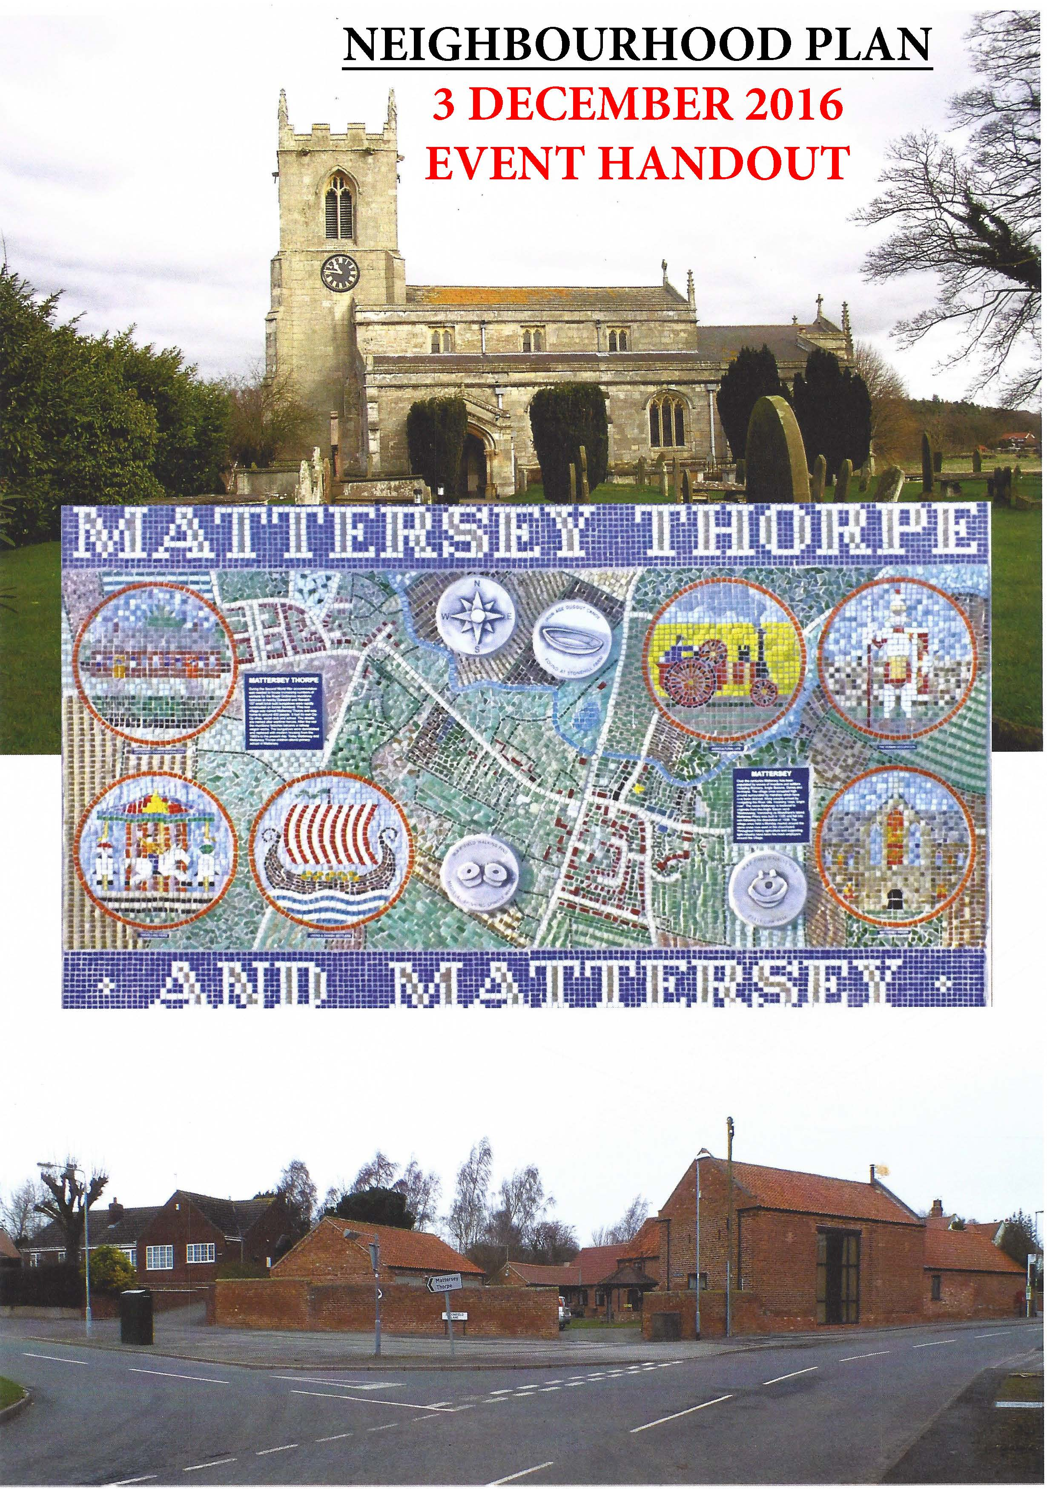

Vision and objectives

The group has been working on a vision for Mattersey and Mattersey Thorpe and a set of objectives which the Neighbourhood Plan should aim to address . These are shown below:

Vision

"In 1 5 years time Mattersey parish will be a thriving community and sensitively-developed area.

It will value the community, the school and it's rural location, and provide people with an opportunity and the facilities to live work and grow .

It will be a parish that has sufficient housing and facilities to attract and retain families, where everyone can live and work and enjoy village life."

Objectives

- Attract young couples and families into the parish to support school numbers.
- Housing design should reflect village character and incorporate energy efficiency.
- Encourage local employment opportunities to support the local rural economy.
- Maintain and where possible, improve public transport, to allow access to services in
surrounding villages .
- Maintain pre-school and primary school education within the village .
- Ensure the parish retains its identity as a rural village.
- Retain and improve upon existing ecreation and community facilities.
- Move towards self-sufficiency in energy generation and usage.

Your comments

We would like your views on the work done so far - In the boxes below, please could you provide comments on whether you would like anything to alter with the vision or objectives and why?
Please feel free to comment on as many aspects as you would like. If you require more space, please use the additional Vision/Objectives comments page towards the end of this form.

What are you Commenting on ? –> Vision Yes / No
Delete or put a line through options that are not applicable
or Objective Yes / No Objective Number >
Comments :
>

What are you Commenting on ? –> Vision Yes/No
Delete or put a line through options that are not applicable
or Objective Yes/No Objective Number >
Comments :
>

What are you Commenting on ? –> Vision Yes/No
Delete or put a line through options that are not applicable
or Objective Yes/No Objective Number >
Comments :
>

What are you Commenting on ? –> Vision Yes/No
Delete or put a line through options that are not applicable
or Objective Yes/No Objective Number >
Comments :
>

What are you Commenting on ? –> Vision Yes/No
Delete or put a line through options that are not applicable
or Objective Yes/No Objective Number >
Comments :
>

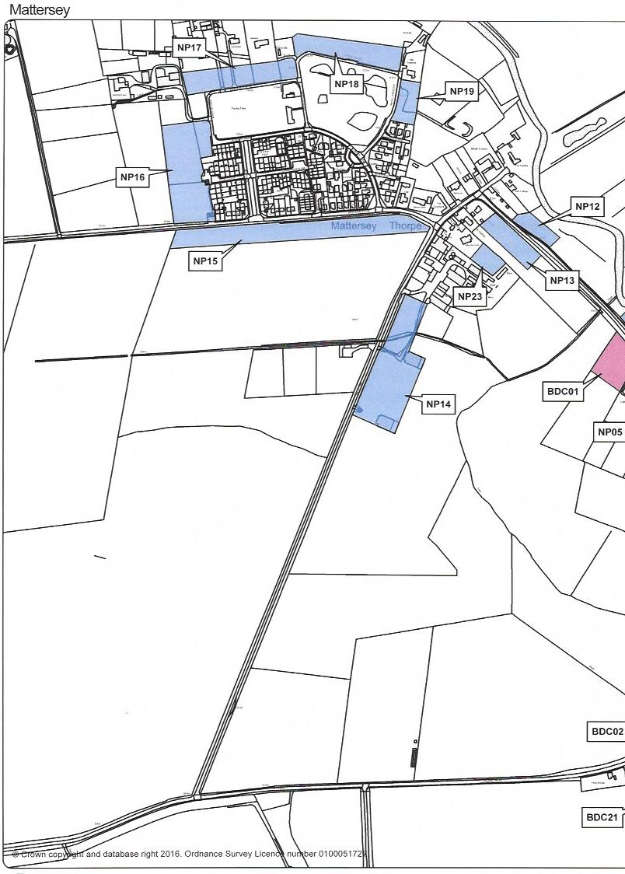
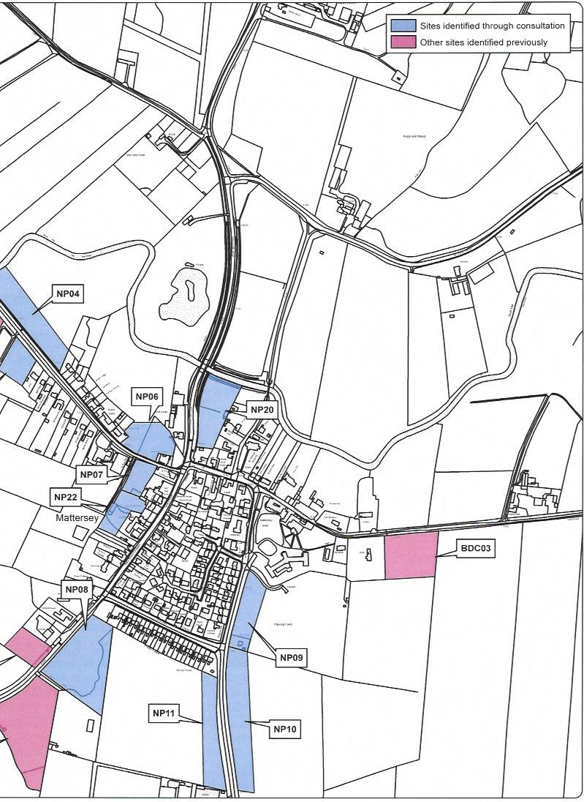
NP05
BDC02
BDC21

Site Assessment Work

The Neighbourhood Plan group are also looking at allocating sites for housing and small workshops or live work units. The sites being considered are shown on the 2 pages before.

Please can you identify the site you would like to comment on,
- Give reasons why you think it would be a suitable/unsuitable site for allocation, plus
- Select the type of development, if any, you think would be suitable, stating why?
Please feel free to comment on as many sites as you would like.
If you require more space, then use the extra Site Allocations Comments page at the end of this form.

Delete or put a line through options that are not applicable
Site reference/number :
Is the site suitable for allocation ? Yes / No Site type : Housing, or Workshops, or Live work units
Why ?
>

Delete or put a line through options that are not applicable
Site reference/number :
Is the site suitable for allocation ? Yes / No Site type : Housing, or Workshops, or Live work units
Why ?
>

Delete or put a line through options that are not applicable
Site reference/number :
Is the site suitable for allocation ? Yes / No Site type : Housing, or Workshops, or Live work units
Why ?
>

Delete or put a line through options that are not applicable
Site reference/number :
Is the site suitable for allocation ? Yes / No Site type : Housing, or Workshops, or Live work units
Why ?
>

Delete or put a line through options that are not applicable
Delete or put a line through options that are not applicable
Site reference/number :
Is the site suitable for allocation ? Yes / No Site type : Housing, or Workshops, or Live work units
Why :
>

Site reference/number :
Is the site suitable for allocation ? Yes / No Site type : Housing, or Workshops, or Live work units
Why :
>
Delete or put a line through options that are not applicable
Site reference/number :
Is the site suitable for allocation ? Yes / No Site type : Housing, or Workshops, or Live work units
Why ?
>

Millennium Green
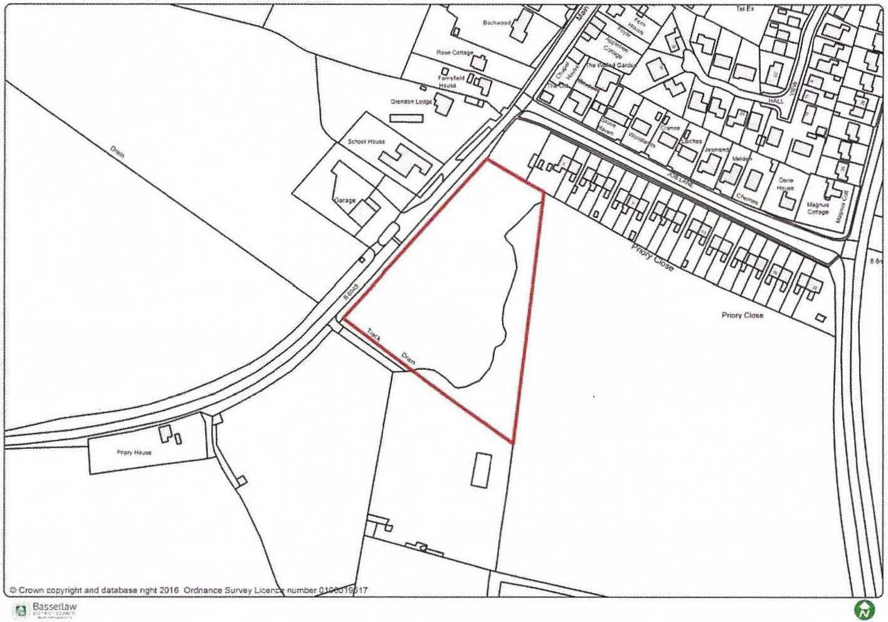
Mattersey NP08

The Neighbourhood Plan group would like to know what you would like to happen with the Millennium Green. There are options being considered which could result in the Millennium Green being relocated and the current site could be considered for housing development.

Should the Millennium Green stay where it is? Yes /No / Not sure (Delete those not applicable)

What would you change about the current Millennium Green ?
>
Where would you want the Millennium Green relocating to (if it was to be moved) ?
>
If you would like to be kept informed of the progress of the Neighbourhood Plan, then please provide your details below:

Name: __ _ _ _ _ _ _ _ _ _ _ _ _ _ _ _ _ _ _ _ _ _

Email address: _ _ _ _ _ _ _ _ _ _ _ _ _ _ _ _ _ _ _ _ _ _

Postcode : _ _ _ _ _ _ _ _
Thank you for your time.
Please ensure that you INCLUDE your Name and Postcode for this form to be valid, then hand in at the Post Office before 24-December 2016
or email this completed file to : j.brogden@btinternet.com
Additional Vision/Objectives Comments sheet

What are you Commenting on ? –> Vision Yes / No
Delete or put a line through options that are not applicable
or Objective Yes / No Objective Number >
Comments :
>
What are you Commenting on ? –> Vision Yes / No
Delete or put a line through options that are not applicable
or Objective Yes / No Objective Number >
Comments :
>

What are you Commenting on ? –> Vision Yes / No
Delete or put a line through options that are not applicable
or Objective Yes / No Objective Number >
Comments :
>

What are you Commenting on ? –> Vision Yes / No
Delete or put a line through options that are not applicable
or Objective Yes / No Objective Number >
Comments :
>

Additional Site Allocation Comments sheet

Delete or put a line through options that are not applicable
Site reference/number :
Is the site suitable for allocation ? Yes / No Site type : Housing, or Workshops, or Live work units
Why ?
>

Delete or put a line through options that are not applicable
Site reference/number :
Is the site suitable for allocation ? Yes / No Site type : Housing, or Workshops, or Live work units
Why ?
>

Delete or put a line through options that are not applicable
Site reference/number :
Is the site suitable for allocation ? Yes / No Site type : Housing, or Workshops, or Live work units
Why ?
>

Delete or put a line through options that are not applicable
Site reference/number :
Is the site suitable for allocation ? Yes / No Site type : Housing, or Workshops, or Live work units
Why ?
>

