Mattersey and Mattersey Thorpe’s Neighbourhood Plan

Site Allocation - Assessment Criteria

Introduction
        - This report assesses all the sites identified through the emerging Neighbourhood Plan for Mattersey and Mattersey Thorpe and their potential for being included as a housing allocation in the final plan. The sites that were considered came from two main sources:
- sites identified through public consultation which the community felt were worthy of consideration (shown in blue below); and
- other sites submitted to the District Council as part of the former Local Development Framework “Call for Sites” in the Strategic Housing Land Availability Assessment (shown in pink).
        - The plan below shows all the sites considered and how they were originally identified. 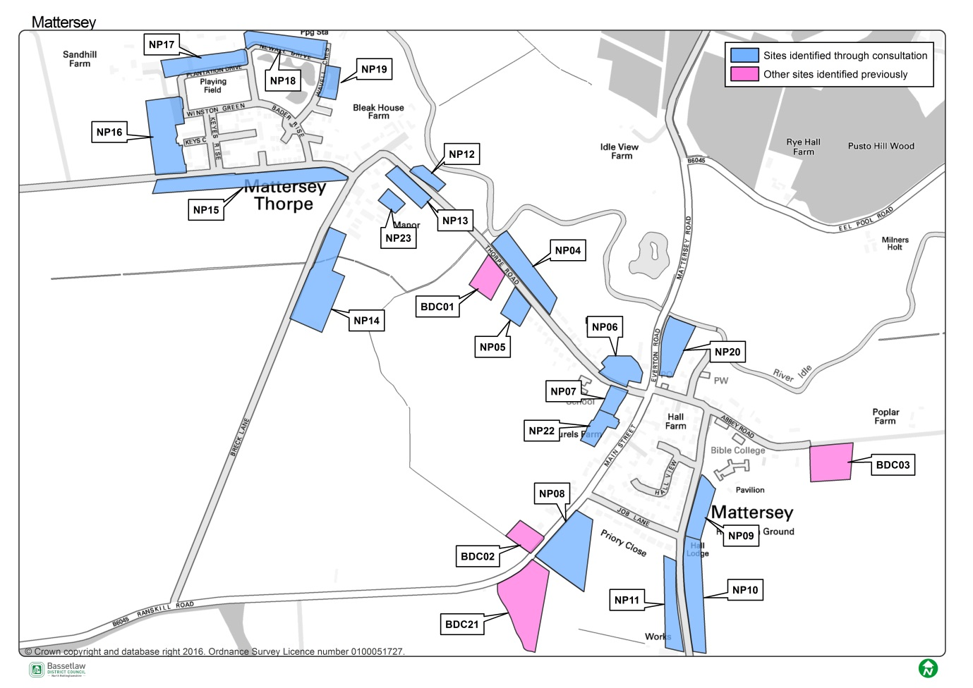
        - This report builds upon the work undertaken as part of the Site Assessment Report (ASR). This document assessed each site’s development potential and included initial feedback from the District Council’s Planning Department based on feedback from various consultees. The ASR will assist with the comparison of sites as any outstanding constraints or issues will be identified to be factored in when determining the site’s suitability for allocation within the Neighbourhood Plan.
        - Following completion of the ASR, it became apparent that there were several potential sites which could be considered as part of the Neighbourhood Plan process. Therefore a further opportunity to screen the potential sites was established by the Neighbourhood Plan group. This is largely based on the District Council’s Site Allocations Screening Methodology, but with specific local criteria set out by the group.

Screening criteria methodology
        - Sites were scored against each criterion using a traffic light system, with green indicating no conflicts, amber indicating some or minor issues (that can be overcome) and red indicating direct conflict. A summary of the results and key observations or concerns in relation to each site can be seen in Appendix 2.
        - The criteria are not ‘weighted’. Although the sites with the highest number of green lights are regarded as more desirable (with fewer adverse effects), sites have not been ranked on this basis alone. Likewise, red lights do not automatically discount sites. Rather, they simply show that the site has issues requiring greater mitigation or has impacts that may be balanced against other factors in the assessment (e.g. its ability to deliver significant local benefits). As such, in instances where sites have accrued amber or red lights, mitigation measures can potentially deliver a range of benefits for the wider community.
        - However, there are three key criteria which would not be allocated if they were to score a red light: the initial assessment made in the Site Assessment Report; the landowner being supportive of the site and whether the local community is supportive of the proposal.

Screening criteria
- Initial assessment made in the Site Assessment Report
        - The initial assessment of sites made through the Site Assessment Report process will be a key factor in determining the suitability of a site to be allocated in Mattersey’s Neighbourhood Plan for housing. The initial assessment will highlight if there are any constraints to the development and are summarised below:
The site WOULD BE suitable for housing based on the consultation comments received through the Site Assessment Report | G
The site MAY BE suitable for housing based on the consultation comments received through the Site Assessment Report | A
The site MAY BE suitable for housing based on the consultation comments received through the Site Assessment Report – but there is a restriction on the numbers of houses (maximum capacity is shown in brackets) | A (5)
The site WOULD NOT be supported based on the consultation comments received through the Site Assessment Report | R

- Is the landowner supportive of developing the site?
        - Ensuring that the landowner of the site is willing and able to bring the site forward for development is a key consideration when determining which sites should be allocated through the Neighbourhood Plan process.
        - Engaging with landowner is part of the Site Selection process and all landowners were invited to discuss their site and any potential issues with the site coming forward. It is fundamental to establish whether the site can be released for development (such as is there a long term lease on the site or a restrictive covenant which would prevent the site being sold?) and the willingness of the landowner to do so.
        - Feedback from each landowner will be a major factor when determining the preferred sites. Without the landowner’s support, it is unlikely that the site will come forward and therefore will have a significant impact on the delivery of the Neighbourhood Plan’s aspirations.
        - Sites will therefore be assessed as follows:
The landowner is in favour of the development taking place | G
There are some concerns about the land ownership or uncertainty | A
No comments were expressed from the landowner/no known issues | W
There are strong concerns about the land ownership or the likelihood of the site coming forward. | R

- Is the local community supportive of the development of the site?
        - Public opinion, where it is based on legitimate planning concerns, is a fundamental consideration in the site allocations process, which is strengthened further within Neighbourhood Planning. As such, on-going public consultation is integral to the continued preparation of the Plan.
        - The level of support expressed by respondents to consultation for or against a particular site, is a significant factor in the decision-making process of the preparation of a Neighbourhood Plan. It will be particularly important where there are a number of sites in the Plan area between which it is difficult to decide or which have equal ‘scores’.
        - It is recognised that land owners or prospective developers may hold their own independent consultation with local communities to gauge support for the development of a site. Where the results of these consultation exercises have been published, they will be considered accordingly. However, conclusions will be primarily based on responses received through consultation undertaken on the Neighbourhood Plan.
        - Consultation responses on each site will be considered as follows (taking account of the fact that some sites may have had no comments made for or against them):
A majority of respondents expressed support for the development of the site for the proposed use | G
A balance of views were expressed for the development of the site for the proposed use | A
No comments were expressed about the development of the site for the proposed use | W
A majority of respondents expressed an objection to the development of the site for the proposed use | R

        - Notwithstanding this, such is the nature of planning that it is often impossible to reach a decision that pleases everyone. Focus will be given to the nature of community views and whether they are related chiefly to factors that can be overcome by the development (e.g. upgrades to the highways network; new school provision; etc.), rather than ‘in principle’ objections.

- Will development of the site be compatible with existing and/or proposed neighbouring land uses?
        - From the point of view of both existing public amenity and that of the occupiers of new development sites, it will be essential to ensure that new development is compatible with its surroundings, taking into consideration, for example, issues of noise, odour, light or privacy. For example, new housing is unlikely to be compatible with an existing heavy industrial site and vice versa. Although there is little in the way of industrial uses within the village, there are some pockets of commercial uses and the potential of these on new housing sites will be considered through the process.
        - Sites will be classified as follows:
Is compatible with existing and proposed uses | G
Likely to be compatible with existing and proposed uses | A
Likely to be incompatible with existing and proposed uses | R

- Will the site result in the loss of best and most versatile agricultural land?
        - Natural England’s Agricultural Land Classification separates land into five grades (and further subdivides grade 3 into 3a and 3b). Grades 1, 2 and 3a are regarded as the best and most versatile agricultural land. Grades 3b, 4 and 5, are seen as being of poorer quality. Under Schedule 5 of the Development Management Procedure Order Natural England must be consulted for single (individual) applications for the following:
‘Development which is not for agricultural purposes and is not in accordance with the provisions of a development plan and involves— (i) the loss of not less than 20 hectares of grades 1, 2 or 3a agricultural land which is for the time being used (or was last used) for agricultural purposes; or (ii) the loss of less than 20 hectares of grades 1, 2 or 3a agricultural land which is for the time being used (or was last used) for agricultural purposes, in circumstances in which the development is likely to lead to a further loss of agricultural land amounting cumulatively to 20 hectares or more’ (Schedule 5, para. x).

        - Advice may also be sought from Natural England regarding the potential impact of cumulative loss of agricultural land (in order to avoid future site allocations being refused planning permission on this basis).
        - The National Planning Policy Framework (NPPF) states (para. 112) that:
‘Local planning authorities should take into account the economic and other benefits of the best and most versatile agricultural land. Where significant development of agricultural land is demonstrated to be necessary, local planning authorities should seek to use areas of poorer quality land in preference to that of a higher quality’

        - Bassetlaw District Council acknowledged that the rural character of Bassetlaw as being one of the District’s most distinctive and valued features. To ensure that loss of land most valuable for agricultural purposes is minimised wherever possible, the Plan should seek to allocate known areas of poorer quality land, unless there are benefits (identified through the other screening criteria) to be achieved that outweigh retention of the land for agricultural use. There are two categories of agricultural land classification within the village, as shown on the map below:

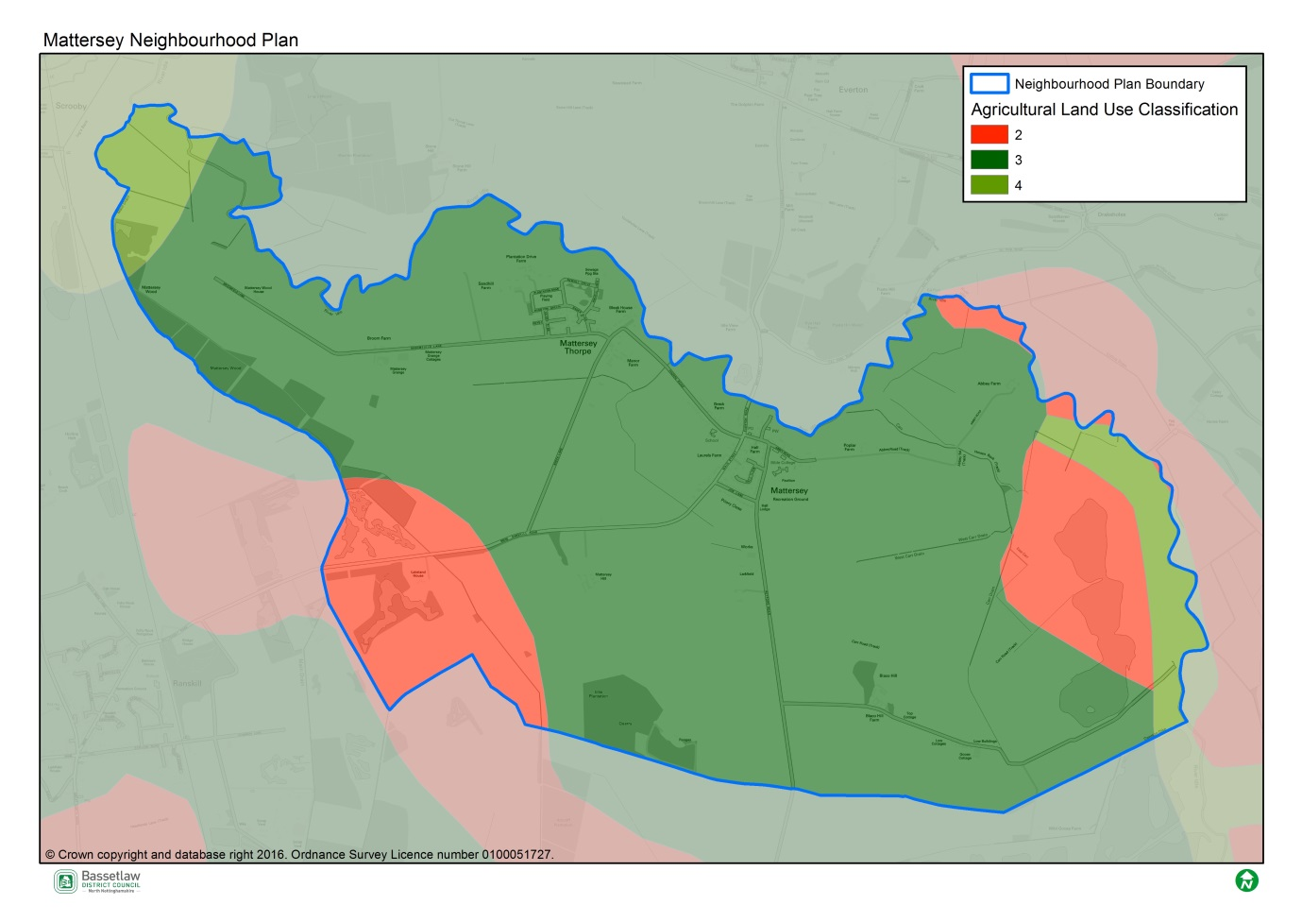

        - Because data to distinguish between grade 3a and 3b land across Bassetlaw is currently unavailable, sites located on grade 3 land will be categorised as amber. It is felt that this represents a precautionary approach that is neither unnecessarily restrictive nor dismissive of the potential value of sites currently in agricultural use.
        - Sites will be assessed as follows:
No impact on agricultural land | G
Impact on grades 3, 4 or 5 agricultural land | A
Impact on grades 1 or 2 agricultural land | R

- Is the site in a landscape character Policy Zone that should be conserved?
        - The importance of protecting the District’s landscape character is recognised in Bassetlaw District Council’s Core Strategy Development Management Policy DM9.
        - Although individual sites have their own characteristics they nevertheless form part of a wider landscape unit. The Bassetlaw Landscape Character Assessment assesses the District in terms of landscape condition and sensitivity, identifying Policy Zones (based on recommended landscape actions) in the following way:
Policy Zone Category | Recommended Landscape Actions
Conserve | Actions that encourage the conservation of distinctive features and features in good condition
Conserve and Reinforce | Actions that conserve distinctive features and features in good condition, and strengthen and reinforce those features that may be vulnerable
Conserve and Restore | Actions that encourage the conservation of distinctive features in good condition, whilst restoring elements or areas in poorer condition and removing or mitigating detracting features
Conserve and Create | Actions that conserve distinctive features and features in good condition, whilst creating new features or areas where they have been lost or are in poor condition
Reinforce | Actions that strengthen or reinforce distinctive features and patterns in the landscape
Restore | Actions that encourage the restoration of distinctive features and the removal or mitigation of detracting features
Reinforce and Create | Actions that strengthen or reinforce distinctive features and patterns in the landscape, whilst creating new features or areas where they have been lost or are in poor condition
Restore and Create | Actions that restore distinctive features and the removal or mitigation of detracting features, whilst creating new features or areas where they have been lost or are in poor condition
Create | Actions that create new features or areas where existing elements are lost or are in poor condition

        - Policy Zones where landscape needs to be conserved are the most sensitive to the potential impacts of new development, whereas areas that need new landscape character creating are least sensitive (and may benefit from appropriately designed schemes that could introduce new or enhanced landscape character features). In Sutton village, there are two policy zones, both of which are conserve and reinforce. See map below:
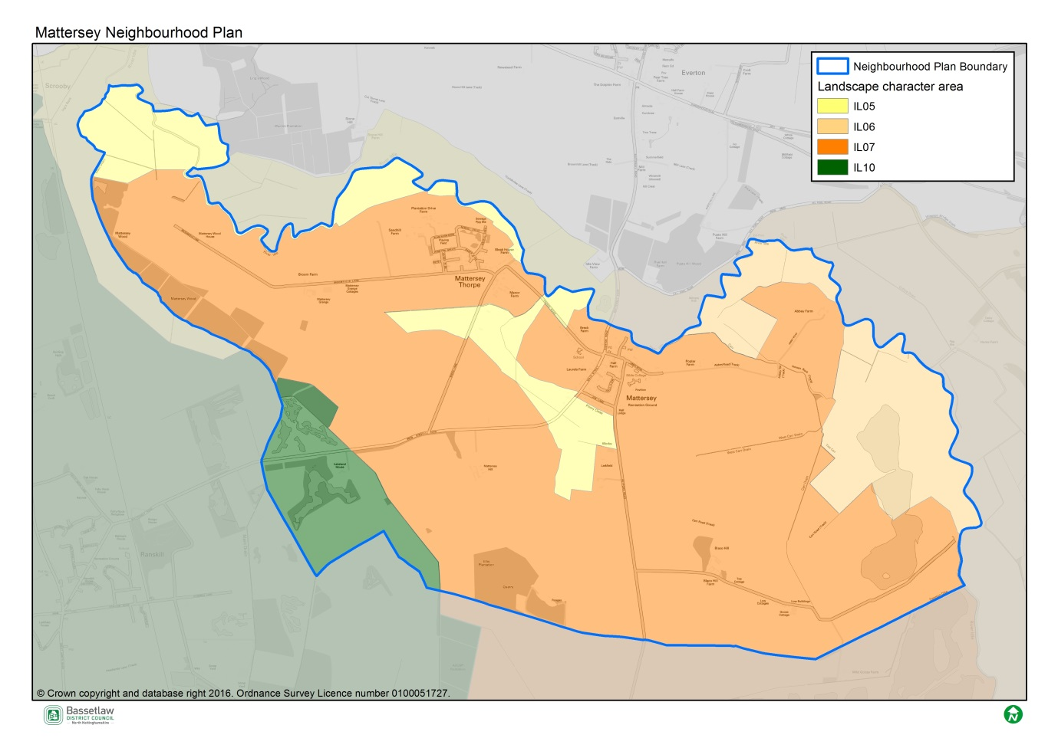
        - Sites will be assessed as follows:
In Policy Zone ‘Create’ | G
In Policy Zone ‘Restore and Create’ | G
In Policy Zone ‘Reinforce and Create’ | G
In Policy Zone ‘Reinforce’ | A
In Policy Zone ‘Restore’ | A
In Policy Zone ‘Conserve and Create’ | A
In Policy Zone ‘Conserve and Restore’ | R
In Policy Zone ’Conserve and Reinforce’ | R
In Policy Zone ‘Conserve’ | R
No relevant Policy Zone – site lies within an urban area | W

- Will the development detract from or enhance the existing built character of the neighbourhood?
        - Many settlements within Bassetlaw have a sensitive built form, which it is desirable to protect and enhance. Conversely, there are a number of areas that would benefit from new development where it would result in a positive impact on a derelict site or poor quality streetscape.
        - Assessing the aesthetic merits of a design is an inherently subjective process and while it is clearly not possible to assess the impact of a development scheme at this early stage, some sites may represent more logical extensions to the existing built form or, in terms of urban design considerations, offer better connectivity/legibility.
        - In Mattersey and Mattersey Thorpe, there is a various character areas ranging from high density more modern development to historic low density roadside development. The allocation of land in/adjacent to these character areas will have to have regard to these character areas and where possible not detract from them. See map below:
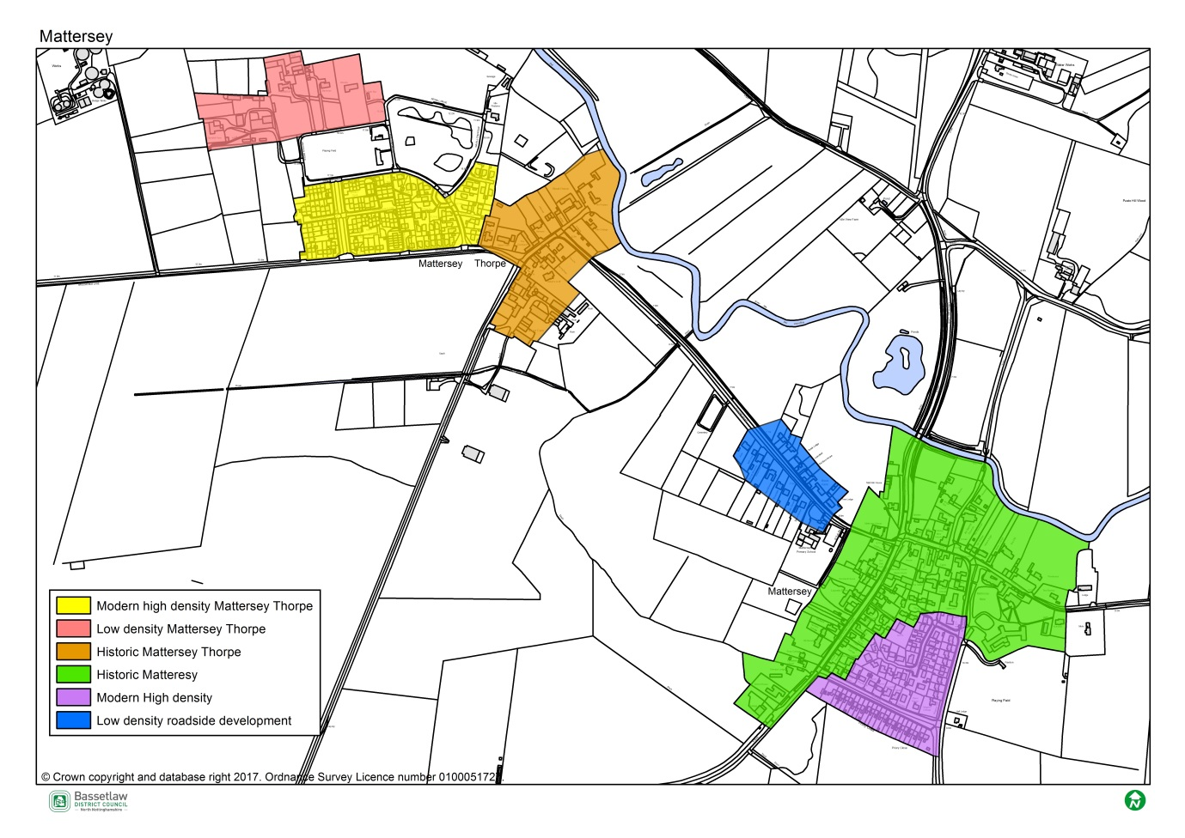
        - Sites will be assessed as follows:
Likely to complement the existing built character/character areas | G
Likely to lead to the existing character of the locality being sightly altered | A
Likely to detract from the existing built character as a standalone development | R

- Will the development detract from or enhance the Natural Environment of the neighbourhood?
        - There are no sites being considered within the Neighbourhood Plan for Mattersey and Mattersey Thorpe with formal designations such as Local Wildlife Site or Sites or Special Scientific Interest. If there were, these would have been assessed as not suitable in Site Assessment Report. However, the potential impact of development on the natural environment is a key consideration. The map below shows the formal designations within the parish area (map to be updated with SSSIs):
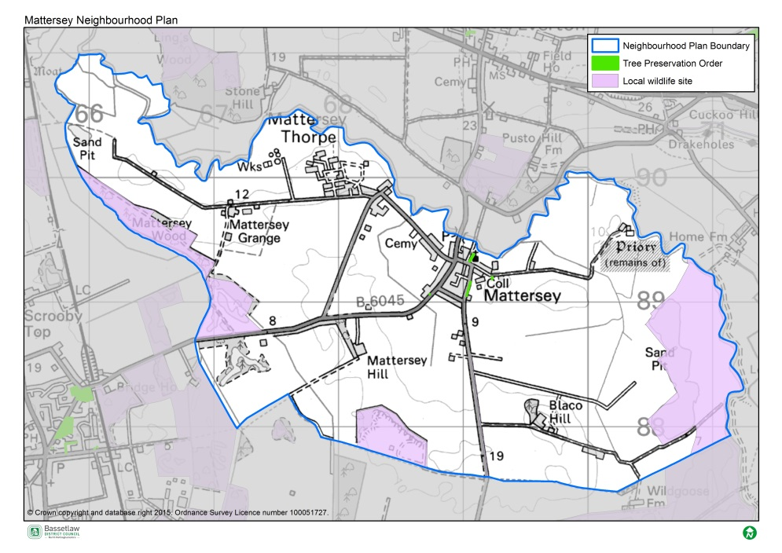
        - Green Infrastructure is a network of multi-functional green spaces in both rural and urban areas and forms an important part of the Natural Environment. The development of a greenfield site may not, by definition, lead to the loss of a Green Infrastructure asset. These green spaces support natural and ecological processes and are integral to the health and quality of sustainable communities.
        - In line with the District Council’s Core Strategy Policy DM9 (Green Infrastructure; Biodiversity & Geodiversity; Landscape; Open Space and Sports Facilities), while it is important to minimise adverse impacts on Green Infrastructure assets, new development can also generate opportunities to protect, enhance, restore and even create habitats and species’ populations. They may also provide opportunities to create, enhance or provide greater access to green spaces. These opportunities will be considered through the screening process, taking into account all information that is available.
        - Sites will be assessed as follows:
Likely to enhance the Natural Environment | G
Unlikely to detract from or result in significant loss of Natural Environment | A
Likely to detract from or result in significant loss of Natural Environment | R
- Will the site impact upon identified heritage assets (including setting)?
        - Whilst some sites that were determined to have a significant adverse impact on identified heritage assets within the original Site Assessment Report have already been discounted. It is deemed necessary that a further assessment is made at this stage to ensure any harmful impacts as well opportunities to enhance assets are identified.
        - Identified heritage assets include: Listed Buildings; scheduled monuments; war memorials; historic wreck sites; parks; historic gardens; conservation areas, archaeological sites as well as non-designated heritage assets (a list of which is maintained by Bassetlaw District Council).
        - In Sutton, the Grade I Listed Church is a significant heritage asset within the village and the preference is to ensure the rural, open character of the surrounding area. Furthermore, there are a number of non-designated heritage assets which will also need to be considered as part of the process. See map below (to be updated):
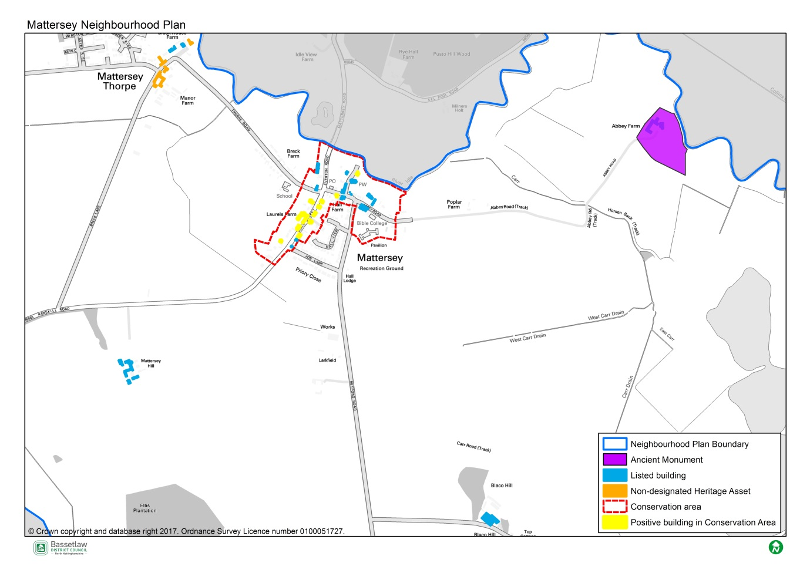
        - Sites will be assessed as follows:
Site has no negative impact or offers potential to enhance identified heritage assets | G
Some likely harmful impacts, however these can be mitigated | A
Likely harmful impacts, mitigation unlikely to resolve this | R
Site has no impact upon identified heritage assets | W
- What impact would developing the site have on existing infrastructure?
        - Mattersey and Mattersey Thorpe are small villages with limited infrastructure and developing sites in the village will need to respect this. There are a number of local infrastructure issues which have been identified through the Neighbourhood Plan process including:
- Are there any issues?
- ??
- ??
        - This criterion assesses the impact of new development on these local infrastructure problems and whether development could improve/enhance the infrastructure or have a harmful impact. The existing services and facilities are shown on the map below:
Map of the services to be included.
        - Sites will be assessed as follows:
Site offers potential to enhance local infrastructure | G
Likely harmful impacts on local infrastructure which is likely to be mitigated | A
Likely harmful impacts on local infrastructure which is unlikely to be mitigated | R
Site has no impact upon existing infrastructure, services and facilities | W

The sites which were submitted through the Land Availability Assessment undertaken by the District Council recently were unavailable at the time of writing. All sites were subsequently checked to ensure that no new sites had been brought the Councils attention.
For the purposes of preparation of the Neighbourhood Plan, public opinion comprises only formal written comments and others that have been recorded throughout consultation on the Plan.
The Town and Country Planning (Development Management Procedure) (England) Order 2010
Copy of this study can be accessed from the planning pages of the Council’s website: www.bassetlaw.gov.uk

