Housing developments
For the purposes of data collection, please can you provide a few details:
POST CODE: DN10 5…………………
HOUSE NUMBER: (optional) …………………………………..

The Neighbourhood Plan group have been advised by Bassetlaw District Council to allocate current view from BDC is that there will be a cap of how much new development could take initially set at 20%. This would mean around allocating land for around 30 houses per
We welcome your views on what sites you would prefer to see development on and an (please consider how the target of 30 houses for each settlement could be achieved). An based on a low density development (large houses with large gardens or spacious bungalow small gardens)
Mattersey (orange sites on the map)
Site reference | Site capacity based on high density development over the whole site (site area) | Are you supportive of housing development on this site? If no, please write “0”. If yes, please state: |  | Would you like to make any more comments relating to this site (extra sheets are available to provide additional comments per site)
 |  | How many houses? | What type of housing you would like?
BDC02 * | Up to 6 houses  (0.32ha)
NP04 (part) | Up to 14 houses  (0.28ha)
NP08 ** | Up to 20 houses  (1.26ha)
NP09 | Up to 14 houses  (0.5ha)
NP10 | Up to 31 houses  (0.96ha)
NP11 | Up to 24 houses (0.62ha)
BDC21 | Up to 10 houses on the roadside  (1.39ha)
NP22 | Up to 5 houses (0.33ha)
* We are also considering BDC02 and NP16 for commercial/live work units. Would you be supportive of this? For these sites, can you make it clear what type of land use you would prefer (either by writing “commercial”, “housing” or “both”) and if appropriate how many houses you would like to see on the site.

FORM COMPLETED BY (if more than one person, please state all names) ………………………………………………………………………………………………………………………………………………………………………………………………………………………………………………………………………………………………………………………………………………………………………..

sites for both settlements, with a view to setting out where the future growth could go. The
place in Mattersey and Mattersey Thorpe – this is currently being consulted on, but was
settlement.

indication of how many houses/what type of housing you would like to see on each site
indication of the scale of development which is possible for each site is provided. These are
plots) through to a high density development (small terrace/semi-detached properties with

Mattersey Thorpe (blue sites on the map)
Site reference | Site capacity based on high density development over the whole site (site area) | Are you supportive of housing development on this site? If no, please write “0”. If yes, please state: |  | Would you like to make any more comments relating to this site? (extra sheets are available to provide additional comments per site)
 |  | How many houses? | What type of housing you would like?
NP13 | Up to 3 houses (0.17ha)
NP14 | Up to 21 houses (1.95ha)
NP15 | Up to 32 houses (2.16ha)
NP16 * | Up to 35 houses  (0.7ha)
NP17 | Up to 20 houses  (0.69ha)
NP18 | Up to 12 houses (0.46ha)
NP23 | Up to 2 houses (0.16ha)

** Millennium Green – this would have to be relocated before the site was suitable for housing (see back page for more information). If you would like to see housing on the site, please write in how many houses. For other comments, please use the back page.

Millennium Green
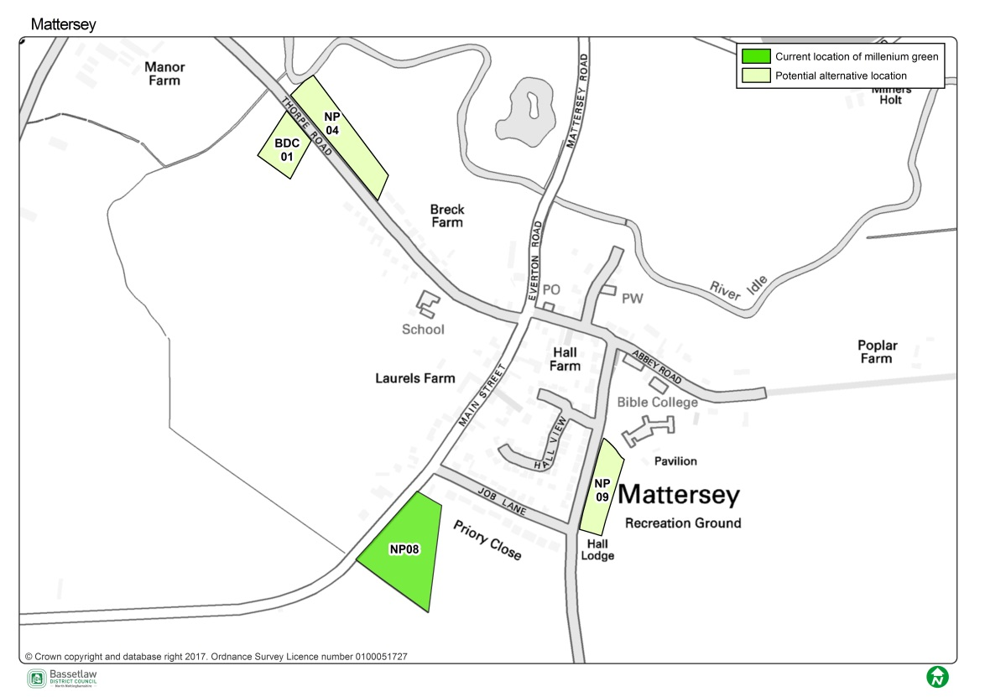
The Neighbourhood Plan group would like to know what you would like to happen with the Millennium Green. Feedback from the last consultation showed that there were two main options:
- retain the current Millennium Green and seek to make improvements; or
- re-locate it and develop on the current site to fund the relocation and improvement.
If the Millennium Green was to be relocated, there were three options proposed: BDC01, NP04 or NP09. (NP04 may have some restrictions due to the tenancy agreement which will need to be further explored). What would you like to happen (and why)?
Preferred Option (BDC01, NP04 or NP09) …………………………………………………………………….………
Why?………………………………………………………………………………………………………………………………………………………………………………………………………………………………………………………………………………………………………………………………………………………………………………………………………………………………………

If you would like to be kept informed of the progress of the Neighbourhood Plan, please can you provide your contact details below:
Email address: ……………………………………………………………………………………………
Name: (optional) …………………………………………………………………………………………..
For more information, please visit http://mandmtneighbourhoodplan.weebly.com/
Thank you for your time.

